**Array of Objects - Review**

Create a Java program to help Ms. Lam keep track of her boys’ shirts in the closet. The program should contain three classes: Shirt, Closet and ClosetRunner (which consists of the main method).

The Shirt Class

• Create all the necessary fields for the class as well as their accessor and mutator methods (get and set). The following information of each shirt needs to be tracked: colour (a String), size (an integer) and year when the shirt is purchased.

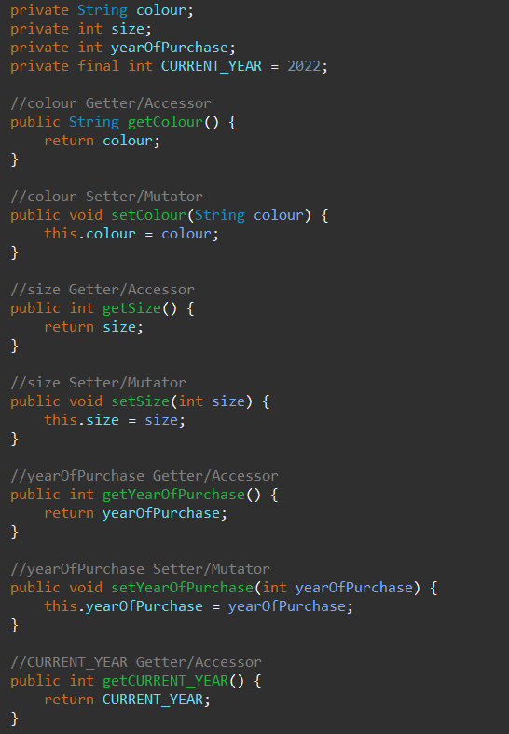

• Create a constructor that initializes the instance variables of the object being constructed.

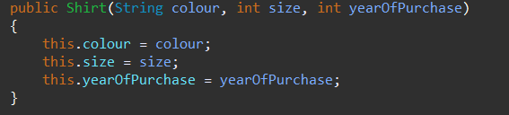

• A method that returns the how old the shirt is (age in years).

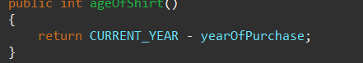

• There should be the toString method which allows the output of the above information in an organized manner.



• Different shirts will be compared on their size, and age, therefore there needs methods for these comparison.

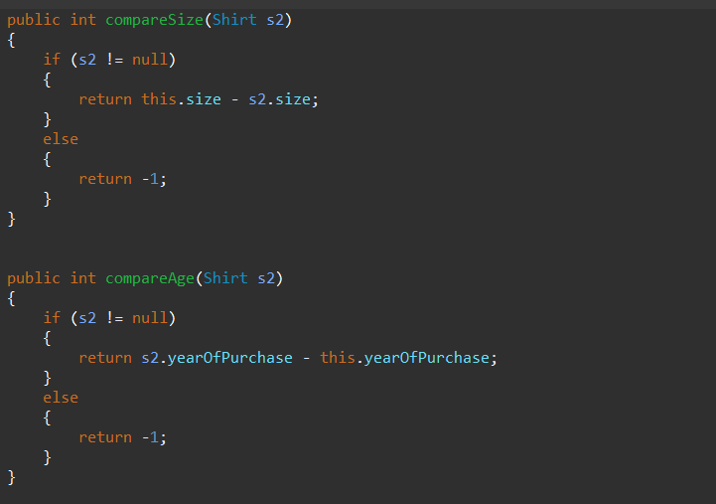

• Two shirts are considered equal if they have the colour and same size.

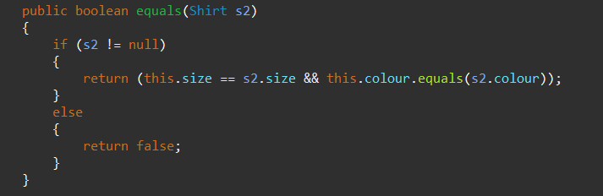

The Closet Class

Create a Java class “Closet” to manage the collection of shirts in the closet. The “Closet” class should contain the following:

• The maximum number of shirts the closet can hold

• The number of shirts that is currently in the close

• An array used to store the shirts

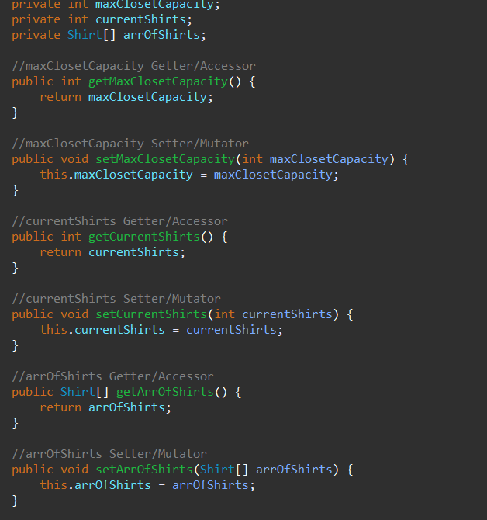

• A constructor that initiate the maximum capacity and create an array of appropriate size

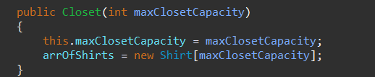

• A method addShirt which takes the information of a shirt as parameter, then create a “Shirt” object accordingly and insert it into the array. It should return a boolean to indicate if the addition is successful.

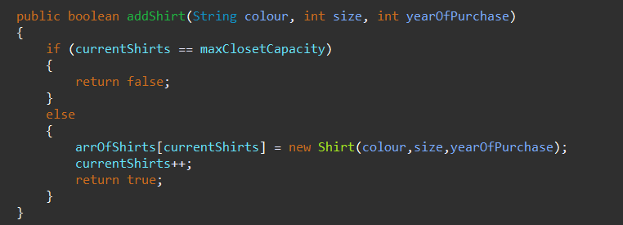

• A method that removes that oldest shirt in the closet (remove the Shirt object from the array). It may be useful to create a private method to find the index of the oldest shirt in the array. If there is more than one shirt with the same oldest age, choose either one. There should not be any “empty slot” in the array after removal, so all the items located after the removed item should be shifted towards the beginning in the array. It should return a boolean to indicate if removal is successful (not successful if the list is empty).

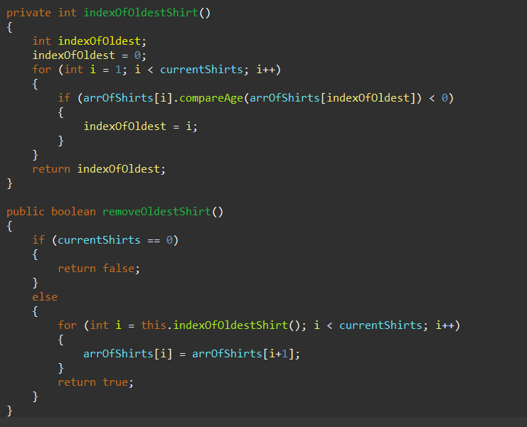

• A method that returns the number of shirts of the given size.

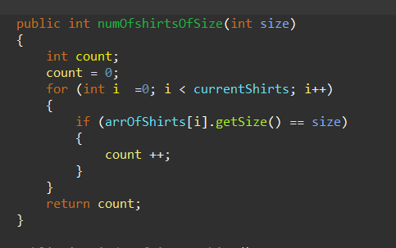

• A method that returns the newest shirt in the closet. If there is more than one shirt with the age, choose either one.

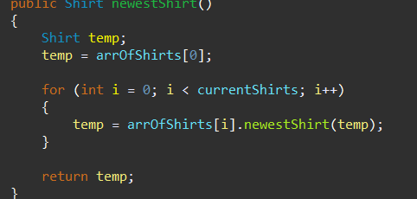

Uses a new method newestShirt from the Shirt class

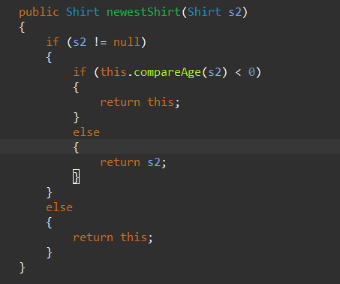

The ClosetRunner Class

• Create the main method that perform the following tasks:

a. Ask user for the maximum capacity of the lab

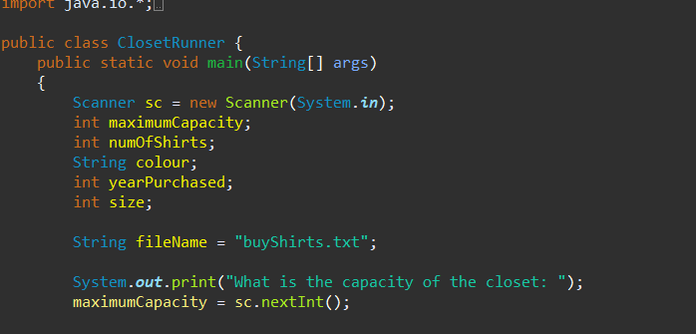

b. Obtain information of each shirt from the text file “boyShirts.txt” and add it to the closet. “boyShirts.txt” is in the following format:

5

red

2

2010 green 10

2017 :

:

:

This file contains information of 5 shirts

Information of shirt #1:

• colour

• size

• year of purchase

Information of computer #2

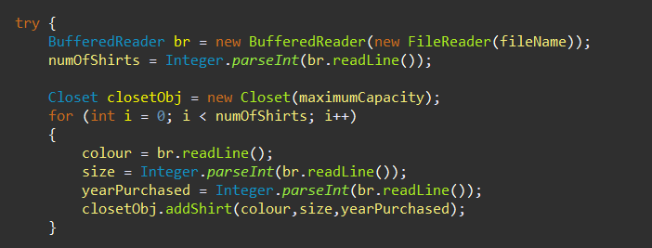

c. Ms. Lam just purchased 5 new shirts. Prompt her for the information for these shirts and add them to the closet. At any point, if the closet is full, remove the oldest shirt from the closet until all new shirts are added.

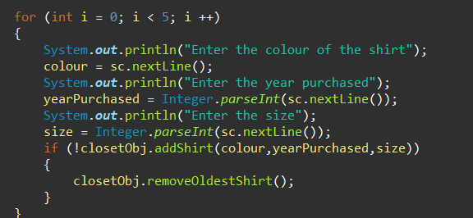

d. Ms. Lam needs to know if there is enough shirts for the boys at a certain size. Prompt her the size and output the number of shirts of that size.

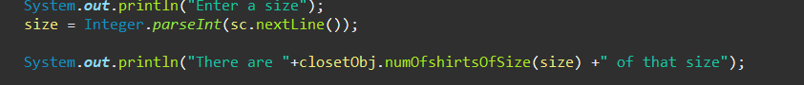

e. Print information of the biggest shirt in the closet.



